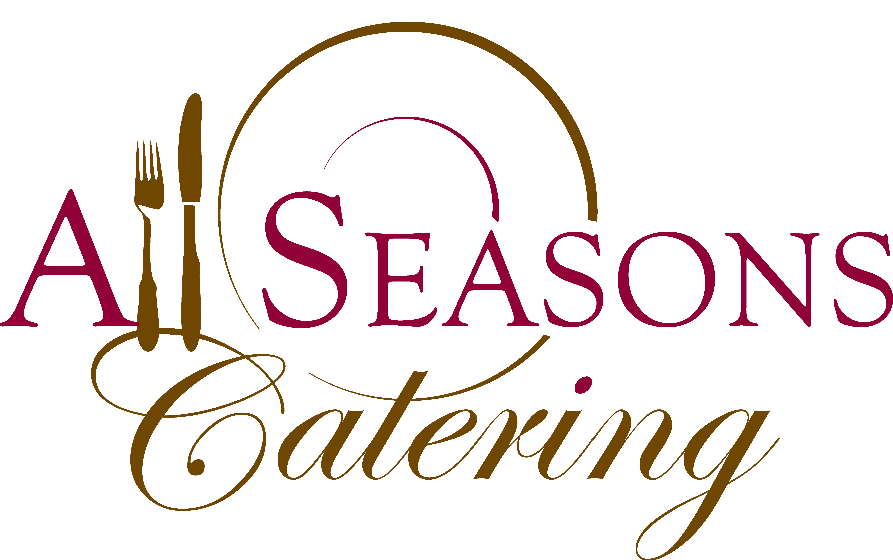
Family Style Menu
Mini Buffet Right at the Guests’ Table! Elegantly Presented on Platters or Bowls For the Guests To Pass Around the Table
Choose Three Salads, Two Vegetables, One Starch,
Entrée is Served to Each Guest

Entrees
$34
Grilled Chicken Bruschetta, Diced Tomato Basil Sauce
Chicken Breast Stuffed with Spinach, Cream Cheese in a Rose Sauce
Traditional Chicken Marsala in a Wild Mushroom Marsala Reduction
Lemon Grilled Chicken, Crispy Fried Capers, Decadent Lemon Butter Sauce
Chicken Saltimbocca, Prosciutto di Parma, Sage Infused Cream Sauce

Pork Tenderloin, Diced Apples, Leeks and Calvados Sauce
Pork Tenderloin with a Sweet Onion Rhubarb Compote
Fresh Roasted Salmon, Lemon Parsley Gremolata
Manitoba Arctic Char, Chili Lime Butter

$38
Beef Tenderloin with Bing Cherry Gastrique
Medallions of Beef with Porcini Cream Sauce
Grilled Flat Iron Steak with Chimichurri Sauce
Grilled Marinated Flank Steak with Romesco Sauce

$34
Portobello Stack, Grilled Vegetables, Seared Polenta Cake,
Roasted Tomato Sauce
Eggplant Braciole, Thin Layers of Eggplant Poached in Olive Oil and Wrapped around a Filling of Eggplant and Roasted Crushed Cauliflower Finished with a Green Salsa Verde
Spinach and Cheese Ravioli in a Pesto Cream Sauce
Eggplant and Zucchini Parmesan

Choose 2 Entrees ~ $40

Pricing Plus PST, GST and 15% Service Charge
Pricing Based on 100 People
Salads
Choose Three

Seasons Tossed Salad
Mixed Field Greens, English Cucumber, Fresh Garden Tomatoes, Shredded Carrots and Assorted Dressing
Spring Salad
Spring Mix, Goat Cheese, Strawberries, Sugar Glazed Pecans, White Balsamic Vinaigrette
Caesar Salad
Crisp Romaine Lettuce, Housemade Croutons, and Parmesan Cheese and our Famous Housemade Caesar Dressing
Traditional Greek Salad
Fresh Garden Tomatoes, English Cucumber, Red Onion, Red and Green Peppers, Kalamata Olives, and Feta Cheese with a Zesty Greek Dressing
Spinach Salad
Fresh Spinach with Sweet Red Onions, Toasted Almonds, Chopped Egg, and Strawberries with a Raspberry Vinaigrette
Coleslaw
Shredded Green and Purple Cabbage with Carrots in your choice of Creamy or Vinaigrette Style Dressing
Pasta Salad
Peppers, Carrots, and Onions tossed in our Secret Dressing
Italian Pasta Salad
Black Olives, Sundried Tomatoes and Parmesan Cheese in an Italian Vinaigrette Dressing
German Style Potato Salad
Red-Skinned Potatoes and Diced Pickles in a Creamy Mustard Dressing
Caprese Salad
Vine Ripened Tomatoes, Mozzarella, Fresh Basil Drizzled with EVOO
Italian Chopped Salad
Assorted Greens, English Cucumbers, Diced Local Tomatoes, Chopped Genoa Salami, Pepperoni, Bothwell Mozzarella and Served with a Vinaigrette
Sicilian
Diced Cucumbers, Tomatoes, Artichoke Hearts, Asparagus Spears, Red Onions, Black & Green Olives, Red & Green Peppers Tossed in Basil Vinaigrette and Finished with Crumbled Feta
Little Italy
Orzo Pasta with Air Dried Roma Tomatoes, Artichoke Hearts, Beefsteak Tomato, Parmesan, and Leek with a Meyer Lemon Vinaigrette
Tabbouleh
Israeli Couscous, Tomatoes, Cucumbers, Roasted Red Peppers, Mint, Parsley, Green Onions, Lemon Juice, and Extra Virgin Olive Oil
Quinoa Pomegranate
Spinach, Black Quinoa, Red Onion, Pomegranate Seeds, and Toasted Almonds Tossed with a Honey Dijon Vinaigrette and Topped with Crumbled Feta
Southwest Quinoa Salad
Quinoa Tossed with Corn, Red Pepper, Black Beans, Cilantro and Smoked Jalapeno Vinaigrette

Farro Pilaf with Dried Cherries and Toasted Almonds

Orzo with Manitoba Greenland Tomatoes and Fresh Basil

Vegetables
Choose Two

Farmer’s Market Vegetable Medley – May Include Carrots, Zucchini, Yellow Squash and Red Bell Pepper Sauteed with Fresh Chopped Garlic and Butter
Asparagus with Lemon Tarragon Butter
Baby Carrots with Manitoba Made Steppler Honey
Baby Carrots and Green Beans Tossed in Chive Butter
Green Beans with Roasted Almonds and Brown Butter
Green Beans with Hazelnuts, Rosemary and Caramelized Shallots
Roasted Broccoli and Cauliflower
Grilled Vegetable Pave
Spiced Roasted Yams, Orange Butter and Pecans
Summer Market Vegetable Medley – Zucchini, Squash, Snow Peas, Cherry Tomatoes and Peppers Tossed in Herb Butter
Roasted Yams with Pecans and Orange Butter
Roasted Squash with Grilled Green Onion Tossed in Honey Thyme Butter
Potato, Sweet Potato and Leek Torte
Roasted Autumn Vegetables – Butternut Squash, Rutabagas, Beets and Parsnips Roasted with Shallots, Sage, Thyme and Oregano
Vegetable Ratatouille

Starch

Chive, Yukon Gold and Manitoba Bothwell Cheddar Potato Cake
Herb and Garlic Roasted Baby Potatoes
Leek Infused Mashed Potatoes
Lemon and Pistachio Pilaf
Wild Mushroom Risotto
Wild Mushroom and Asparagus Risotto
Lemon and Herb Risotto Cakes
Butternut Squash Risotto Cakes
Yukon Gold and Sweet Potato Pave
Gnocchi in a Basil and Smoked Tomato Cream Sauce
Butternut Gnocchi in a Sage Butter Sauce
Twice Baked Potato
Smashed Potatoes with Garlic, Butter and Topped with Parsley, Chives and
Parmesan Cheese
Manitoba Organic Pumpkin Polenta
Savoury Bread Pudding with Butternut Squash, Sage and Parmesan Cheese
Potato Gratin with Manitoba Bothwell Cheddar and Braised Leeks
Risotto Pave with Lemon and Fresh Herbs
Manitoba Maple Sweet Potatoes

Pricing Includes Set Up, Professional Serving Personnel, All China, Silverware, Water and Wine Glasses, Coffee and Tea Service, Floor Length Linens, Linen Napkins and Clean Up
Cap off Dinner with a Beautifully Presented Mini Dessert Station
Choose 8 Types
$6.95
Pies
Mini Lemon Meringue Pie
Mini Boston Cream Pie
Peanut Butter Tarts
Mini Pumpkin Pies
Mini Banana Cream Pie
Warm Apple Crumb Minis
Mini Apple Crisp Cups
Mini Strawberry Tarts
Mini Fruit Tarts
Mini Apple Pie
Tiny Pecan Tarts
Butter Tarts

Chocolate
Peanut Butter Chocolate Balls
Mini Peanut Butter Cup Brownies
Almond Chocolate Coconut Cups
Chocolate Bourbon Caramel Truffles
Toasted Coconut White Chocolate Truffles
Orange Scented Grand Mariner Truffles
Bourbon Pecan Truffles
Cappuccino Mousse Cups
Mini Chocolate Eclairs

Cakes
Mini Strawberry Shortcakes
Mini Cheesecakes
Mini Carrot Cakes
Mini Tia Maria Cakes
Mini Pumpkin Cakes
Mini Cupcakes
Cookies ‘n’ Cream Minis

Cookies
Macarons
Mini Chocolate Chip
Mini Sugar Cookies
Classic Cannoli with Caramel Mousse
Chocolate Caramel Cookie Bars
Blueberry Crumble Cookie Bars
Raspberry Bars

